GENCP02: C-PROGRAMMING FUNDAMENTALS

Date: 09th Dec 2025
Period: 08:00AM – 12:00AM

SCHOOL COMPREHENSIVE ASSESSMENT
SECTOR: ICT & MULTIMEDIA
RTQF LEVEL: 3
TRADES: NETWORKING AND INTERNET TECHNOLOGY

100
MARKS:
DURATION: 3 HOURS
INSTRUCTIONS TO CANDIDATES:
- This Exam paper is composed of THREE (3) Sections (A, B and C). Follow the instructions given below, and answer the indicated questions for a total of 100 marks
Section A: Attempt all questions. (55 Marks)
Section B: Attempt THREE (3) in among 4 questions this section. (30marks)
Section C: It is must to do that question. (15marks)
2. Use only blue pen or black pen.

SECTION A: ANSWER ALL QUESTIONS (55 Marks)

A. FILL IN THE BLANKS (10 marks)
Fill in each blank with the correct word from the brackets.
- A set of instructions written to perform a task is called a computer program.
- A system of rules used to write instructions for a computer is called a programming language.
- The symbol used for comments in C is //.
- A flowchart uses standardized symbols.
- C language was developed by Dennis Ritchie.
- A constant value that cannot be changed is declared using const.
- The operator used to assign values to variables is =.
- A computer program must follow correct syntax.
- A flowchart is a graphical representation of an algorithm.
- High-level languages include Python.

B. MULTIPLE CHOICE QUESTIONS (10 marks)
Circle the correct answer.
- Which of the following is a low-level language?
a) Python b) C c) Java d) Assembly
- Which of the following is NOT a basic C data type?
a) char b) float c) bool d) int
- The logical AND operator in C is:
a) && b) || c) and d) &
- Which IDE is commonly used for C programming?
a) AutoCAD b) Dev-C++ c) Photoshop d) Blender
- Which of the following is a correct declaration?
a) data number; b) set number; c) int number; d) var number
- The if statement is used for:
a) Debugging b) Output c) Looping d) Decision-making
- The parallelogram in a flowchart represents:
a) Input/Output b) Start/End c) Processing d) Decision
- A sequential algorithm follows:
a) Boolean steps b) Machine steps c) Ordered steps d) Random steps
- The equality comparator is:
a) += b) == c) <> d) =
- The function where every C program begins execution is:
a) run() b) begin() c) start() d) main()

C. TRUE/FALSE QUESTIONS (10 marks)
Write TRUE or FALSE.
- Computer program is a process of writing instructions for a computer. False
- Flowcharts use arrows to show direction of the procedure. True
- Variables in C can change their values during execution. True
- The else-if statement allows checking single conditions. False
- Operators does NOT help in performing operations on data. True
- An algorithm must have a clear start and end. True
- Constants cannot be changed after declaration. False
- The diamond symbol represents input/output in a flowchart. False
- Logical operators are used in decision making. True
- A C compiler translates machine code to source code. False

D. MATCHING QUESTIONS (8 marks)
Match items in Column A with Column B.
Column A | Column B | Answer
1. Flowchart | A. Coding environment | 1. ___E
2. Algorithm | B. Fixed value | 2. ___G
3. Constant | C. Defines type of data | 3. ___B
4. Compiler | D. Decision-making | 4. ___F
5. If statement | E. Shows program steps using symbols | 5. ___ D
6. Variable | F. Converts source to machine code | 6. ___H
7. IDE | G. Step-by-step procedure | 7. ___A
8. Data type | H. Stores changeable data | 8. ___C

E. ORDERING QUESTIONS (4 marks)
Arrange the steps of setting up and using a C programming environment in correct order. Each correct placement = 0.8 marks
Correct order:
- Install a C compiler
- Write the source code
- Save the file with a .c extension
- Compile the program
- Run and debug the program

F. SHORT-ANSWER QUESTIONS (13 marks)
- List any four types of programming languages. (4 marks)
Any three of the following (1 mark each):
- Machine language
- Assembly language
- High-level language
- Procedural language
- Object-oriented language
- Scripting language
- Functional language
- Give five purposes of programming languages. (5 marks)
(Any 4 – 1 mark each)
- To communicate instructions to a computer
- To automate tasks
- To solve problems efficiently
- To develop software applications
- To control hardware
- To perform calculations
- To process data
- To build systems (embedded, desktop, mobile)
- Identify two flowchart symbols and state their uses. (2 marks)
(1 mark each) Examples:
- Oval/Terminal – Start or End of a program
- Parallelogram – Input/Output
- Rectangle – Processing
- Diamond – Decision
- Define a token in C and give four examples. (2 marks)
- Definition (1 mark):
A token is the smallest individual unit in a C program.
- Examples (any four = 1 mark):
Keywords, Identifiers, Constants, Operators, Punctuation/Symbols.

SECTION B: ANSWER ANY THREE (30 Marks)

------------------------------------------------------------------ Each question carries 10 marks.
  - Explain the different data types in C and give examples.
Suggested marking:
- Explanation of each type: int, float, char, double, void (5 marks)
- Examples for each (5 marks)
  - Describe the steps of developing a flowchart and explain its importance in programming.
- Steps: define problem, identify inputs/outputs, determine steps, draw symbols, check flow (5 marks)
- Importance: clarity, problem understanding, reduces errors, documentation, planning (5 marks)
  - Discuss the structure of a C program and give an example.
- Preprocessor directives (2 marks)
- Functions (2 marks)
- Variables (2 marks)
- Statements (2 marks)
- Comments (1 mark)
- Example program (1 mark)
4. Explain the main types of operators in C with examples.
- Arithmetic operators (2 marks)
- Logical operators (2 marks)
- Relational operators (2 marks)
- Assignment operators (2 marks)
- Increment/Decrement (2 marks)

SECTION C: THIS QUESTION IS MUST (15 Marks)

-------------------------------------------------------
A trainer needs a simple program to process students’ marks in three subjects.
Write a complete solution that includes:
Question 1. A Flowchart showing the steps to:

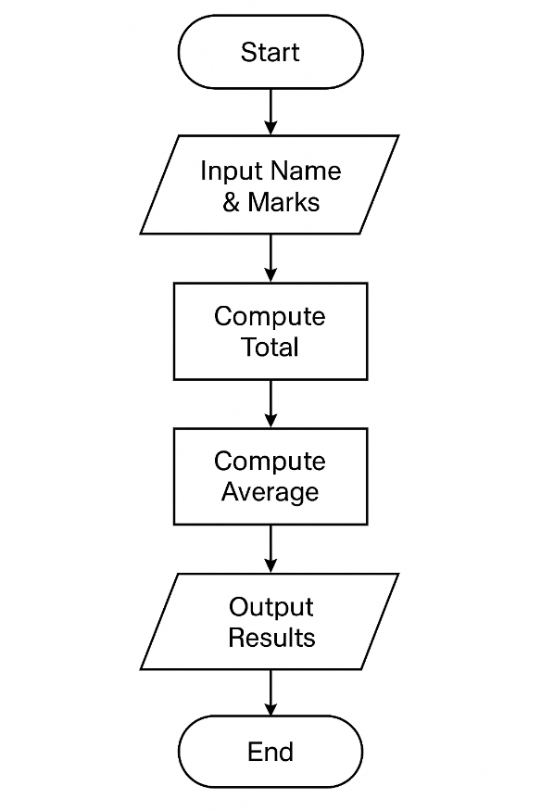
Step | Description | Symbol
1 | Start | Oval
2 | Input student name & marks | Parallelogram
3 | Compute total | Rectangle
4 | Compute average | Rectangle
5 | Output results | Parallelogram
6 | End | Oval

Question 2. An Algorithm describing the steps to perform the same task. (5 marks)
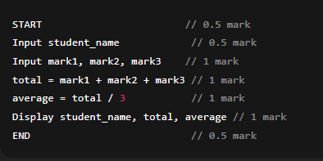
Question 3. The c program codes of that above Flowchart and Algorithm (5 marks)
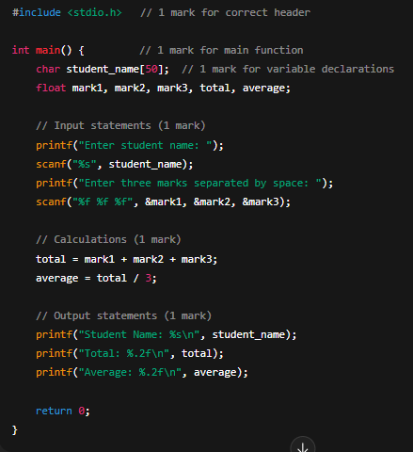
GIVE IT YOUR BEST!

